Harmonic Content: A Musical and Visual Art Installation
ECE4723 Senior Design Project Final Report
Section: A Group: S01
Advisors: Steve Kenney, Noah Posner

Georgia Institute of Technology
North Ave NW, Atlanta, GA 30332

William Kennedy (EE), wkennedy33, wkennedy33@gatech.edu
Andrew Kim (CmpE), akim396, akim396@gatech.edu
Savannah Hearn (CmpE), shearn6, shearn6@gatech.edu
Owen Rohm (ID), orohm3, orohm3@gatech.edu

Submitted
2021 December 13

Table of Contents
Executive Summary
Nomenclature
- Introduction
  - Objective
  - Background
- Design Ideation
  - Constraints for Shape and Display
  - Proposed Design Solutions
  - Market Research
- Technical Specification
  - Hardware
  - Software
- Demonstration
- Cost Analysis
- Conclusion
- Leadership Roles

References
Appendix

Executive Summary
“Harmonic Content'' is an art installation demonstrating signal parameters through music, light, and visualization. It was created for the Georgia Tech School of Electrical and Computer Engineering, and will be mounted on the wall in the Van Leer building. Primarily, it consists of a modular four-voice analog musical synthesizer, with a custom, whimsical user interface designed to encourage passersbys to play music. Above the synthesizer is a mesmerizing LED display that changes to reflect the music. Both the visual LED display and the auditory experience of the music explore the concept of harmonic relationships. In addition to being played through its user interface, it has an autonomous mode that activates when no user input is detected for some time. In this mode, it plays pleasant chord progressions or melodies quietly.
Harmonic Content is designed to be modified and expanded. The project is documented and open source, so that future students can create custom analog filters, add special effects, or play their own musical programs on it.
The installation cost around $4000 in materials, including synthesizer modules, building materials, and electrical components. It measures approximately 6’ x 4’ x 14”.
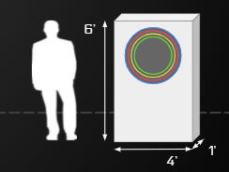
Figure 1. Scale of the installation

Nomenclature
DAC: A Digital-to-Analog Converter takes digital signals and converts them to analog signals, most commonly digital to audio signals.
Eurorack: A standard format for modular synthesizers, in which oscillators, filters, and amplifiers are controlled via control voltage signals are passed through 3.5mm mono jack cables.
I2C: a synchronous, multi-controller/multi-target, packet switched, single-ended, serial communication bus
MIDI: Musical Instrument Digital Interface is a commonly used protocol for communicating music. It includes musical features including pitch, velocity, location, tempo, and more.
SPI: Serial Peripheral Interface is a 3-wire communication interface used for short-distance communication, primarily in embedded systems.
Polyphonic: capable of producing more then one note at a time
MCU: microcontroller unit (in this case Teensy 4.1)

Harmonic Content: A Musical and Visual Art Installation

1. Introduction
Harmonic content is an interactive public art sculpture combining visual and audio elements. The heart of the installation includes a custom built synthesizer that can be controlled by users, and a visual element that visually represents signal characteristics of the notes being played in real time. Additionally, the sculpture will be designed to allow expandability by future musicians and engineers. This document gives a high-level overview of the project’s appeal, its design aspects, the expected development timeline, and each team member’s contributions.

1.1 Objective
Interact: The main role of Harmonic Content is as an interactive art installation. Users can play notes on the instrument using novel and intuitive input elements to control pitch, volume, and signal characteristics. Based on the notes being played, a visual element reacts providing visual cues to the sculpture, connecting sound and sight. Both audio and visual elements will be pleasing and appropriately nonintrusive for presence in a public space.
Visualize: Harmonic Content is more than a toy. In addition to being artistic and playful, the sculpture has educational impact as a resource for students studying electricity. Its multimodal representation of analog signals encourages rumination on mathematical concepts including frequency, amplitude, filtering, and rise or fall times, as these concepts are expressed in different ways.
Expand: The sculpture will have significant hardware expandability. Future parties will be able to add their own module that they can plug into the system to either modify the sound output or add a visual element. Expandability should promote creativity as well as education and engineering of audio, hardware, and embedded systems.

2. Design Ideation

2.1 Constraints for Shape and Display
The project will be installed in a hallway in a classroom building, so it is reasonably transportable, not too loud, and electrically sound for connection to a common wall outlet. Additionally, since it is designed to be expanded by future users, it has documented and standardized voltages and control signals. These constraints are summarized in the table below.
Main Power source | 120V AC | Installation can be powered by wall power
Size | 6’ x 4’ | Transportable by several people
Noise | 50 dB | Max sound levels created
Surge Protection | Yes | Ensure circuit protection
Module Voltage | 5V/12V/-12V | Voltage to modules
Control signals | 3.3V | Voltage into Teensy Microprocessor

In addition to these constraints, there are some other guiding principles that govern the visual and spatial design of the sculpture. It is engaging to play, while remaining approachable and inviting.

2.2 Design Solutions
The microcontroller uses a MIDI interface to control notes being played on the synthesizer. The MIDI interface is a serial bus that is coded for musical notes. The envelopes are created by taking advantage of the control voltages available on the MIDI module.
A patch panel is used that fits in the eurorack standard so all the signals from the MCU can be sent to different modules and signals can be sent into the MCU from our user interface. The visual subsystem will have its own microcontroller and signals must be sent to that for processing and output through the I2C bus. Both the main system and visual system will need their own PCB.

3. Technical Specification

3.1 Hardware
The proposed device design consists of three main parts: a user interface, a central control system, and a synthesizer module rack, as shown in the diagram below.
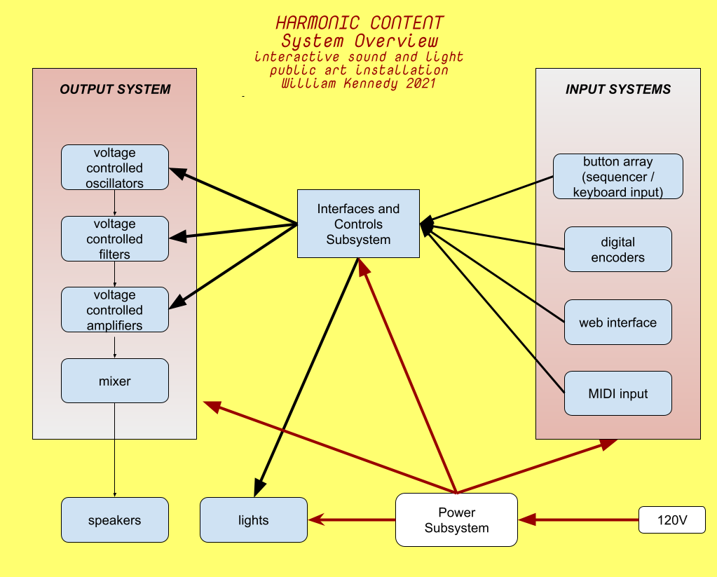
Figure 2 . Overall system overview

The central control system consists of two Teensy Microcontrollers, the first of which manages the musical elements of the sculpture. It will take in 0-3.3v analog and digital signals from the user interface elements and process them. MIDI signals are sent out to control the synth modules pitch and envelope. The second Teensy Microcontroller controls the light display and associated motors. It communicates with the first over I2C.
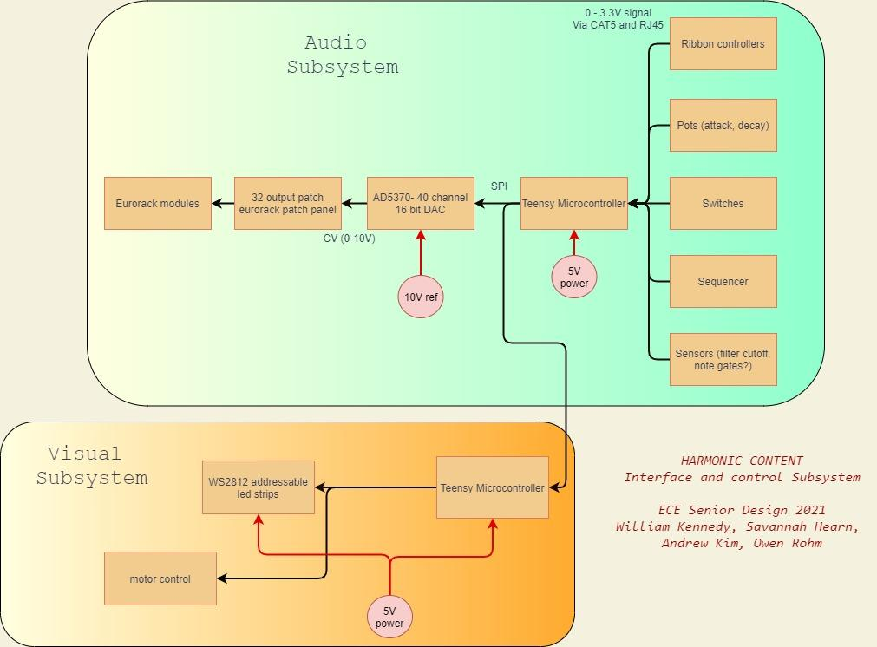
Figure 3. Interface and control subsystem block diagram

The musical signals present in the device are summarized in the table below. Additionally, wiring for totally unanticipated signals, whether ones that become necessary later on or ones that are added as expansions, are also included.
Signal Name | Format | Source | Destination
Pitch Input | Analog 0-3.3v | User Interface | Central Teensy
Note Characteristics | Analog 0-3.3v | User Interface | Central Teensy
Unused | Analog or Digital | User Interface | Central Teensy
Teensy Com | I2C | Central Teensy | Visual Teensy
MIDI I/O | Serial | Central Teensy | Synth Panel
Extra SPI | SPI | Central Teensy | Undetermined
Synth Control Signals | Digital SPI | Central Teensy | DACs
Synth Control Voltages | Analog 0-10v | DAC | Synth Panel
Unused | Analog 0-10v | DAC | Synth Panel

Providing extra connections gives a wide ability for future users to explore creative effects not limited to amplitude modulation, frequency modulation, cutoff frequency envelope, and more. Additionally, extra access to the SPI bus is provided from the central Teensy so that future devices can be added to the bus.
The central teensy is mounted on a circuit board with the following schematic.
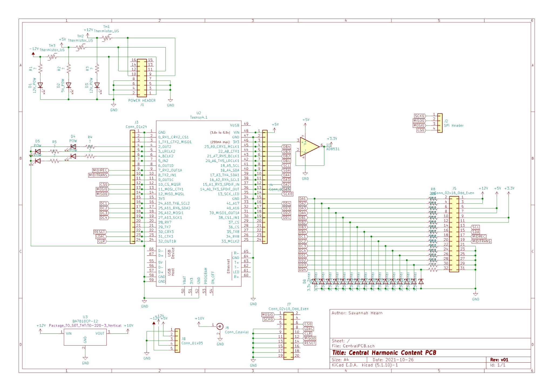
Figure 4. Central PCB schematics

3.2 Software
A Teensy microprocessor houses the software. In normal operation, the software regularly scans for changing signals from the user interface and output control signals for the display and other peripherals. The software also controls the outputs when the machine is in idle state and when it is being tuned.
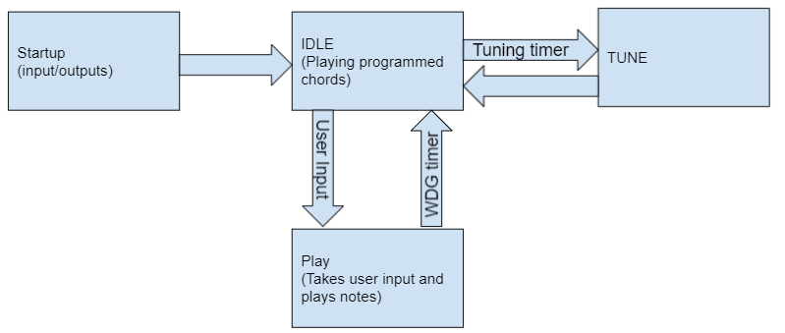
Figure 5. Main Software architecture for state machine control
The startup state runs immediately after the system is powered on or the device is reset. At startup, the configuration variables for the inputs, outputs, and control variables will be set. After setup is completed, the software puts the machine into idle state.
In idle state, the machine runs in a mode that plays preprogrammed notes. This is to ensure the machine is pleasant visually and musically when not being used. This state reads inputs to be pushed into the user controlled state, but otherwise ignores all input data. After a while, the machine will go into the tuning state after a timer runs out. The functionality of this state is largely be based on the software that plays notes, but will be automated in the software.
The oscillators need to be tuned to ensure they are musically pleasant. In the tuning state, the software will output digital control for the oscillators and output a controlled note to tune the oscillators. After this is complete, the machine returns to the idle state.
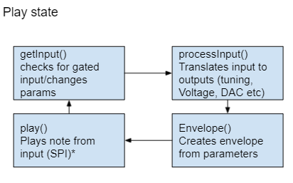
Figure 6. The software loop to control the play state
In the play state, the software runs in a loop that reads the user inputs and processes them for output. The software needs to translate the raw inputs to outputs that can be used for the DAC, display, and peripherals. Additionally, some modifications to the signals will be added to add usability and intuitivity of the system. The envelope function steps up the control voltage when a note starts being played and steps down when a note stops being played. Finally, the output signals are generated.
In the overall design, the software is meant to be modified very little by any potential expansion projects. In the case the software needs to be added to or modified, instructions will be created to flash the new software. Additionally, the current software has accompanying documentation and is granularized in a way that promotes simple expansion.

4. Demonstration
The installation premiered at the Senior Design Capstone Expo on December 7th to huge success. It was a visually impressive and eye-catching sight. Unfortunately, with the tight build and install timeline, it wasn’t fully functional as described, all the electrical system were built, wired and functional, but since there was virtually no time with the machine after the systems were wired, the software was sparse and buggy. Passerby’s could come up to the machine and play with the large sliders and hear the pitch change up and down and push the button and hear an envelope being applied to the oscillator though. The dual function buttons did not work, only the momentary button worked, and the visual output system with the LEDs and motors did work, but it remained in static mode, as there were last minute software bugs communicating between the central MCU and the visual MCU.
Specifications table and results
Spec. | quatifiation | description | achieved?
Main Power source | 120V AC | Installation can be powered by wall power | there was a large 12VDC wall wart power supply for the LEDS, motors, and electronics and 18VDC wall wart power supply for the synthesizer
Size | 6’ x 4’ | Transportable by several people | 6’ x 4’ x 14”
Noise | 50 dB | Max sound levels created | not tested, but could be as loud as 85dB estimated
Surge Protection | Yes | Ensure circuit protection | yes
Control of audio modules | MIDI to CV | can the machine be played by the external controls | yes, attack and decay controls didn’t work, others did not have consistent behavior
control of LEDS and motors | I2C bus | Voltage into Teensy Microprocessor | I2C bus worked briefly, but there was no time to troubleshoot. LEDS and motors worked and data was being sent successfully.

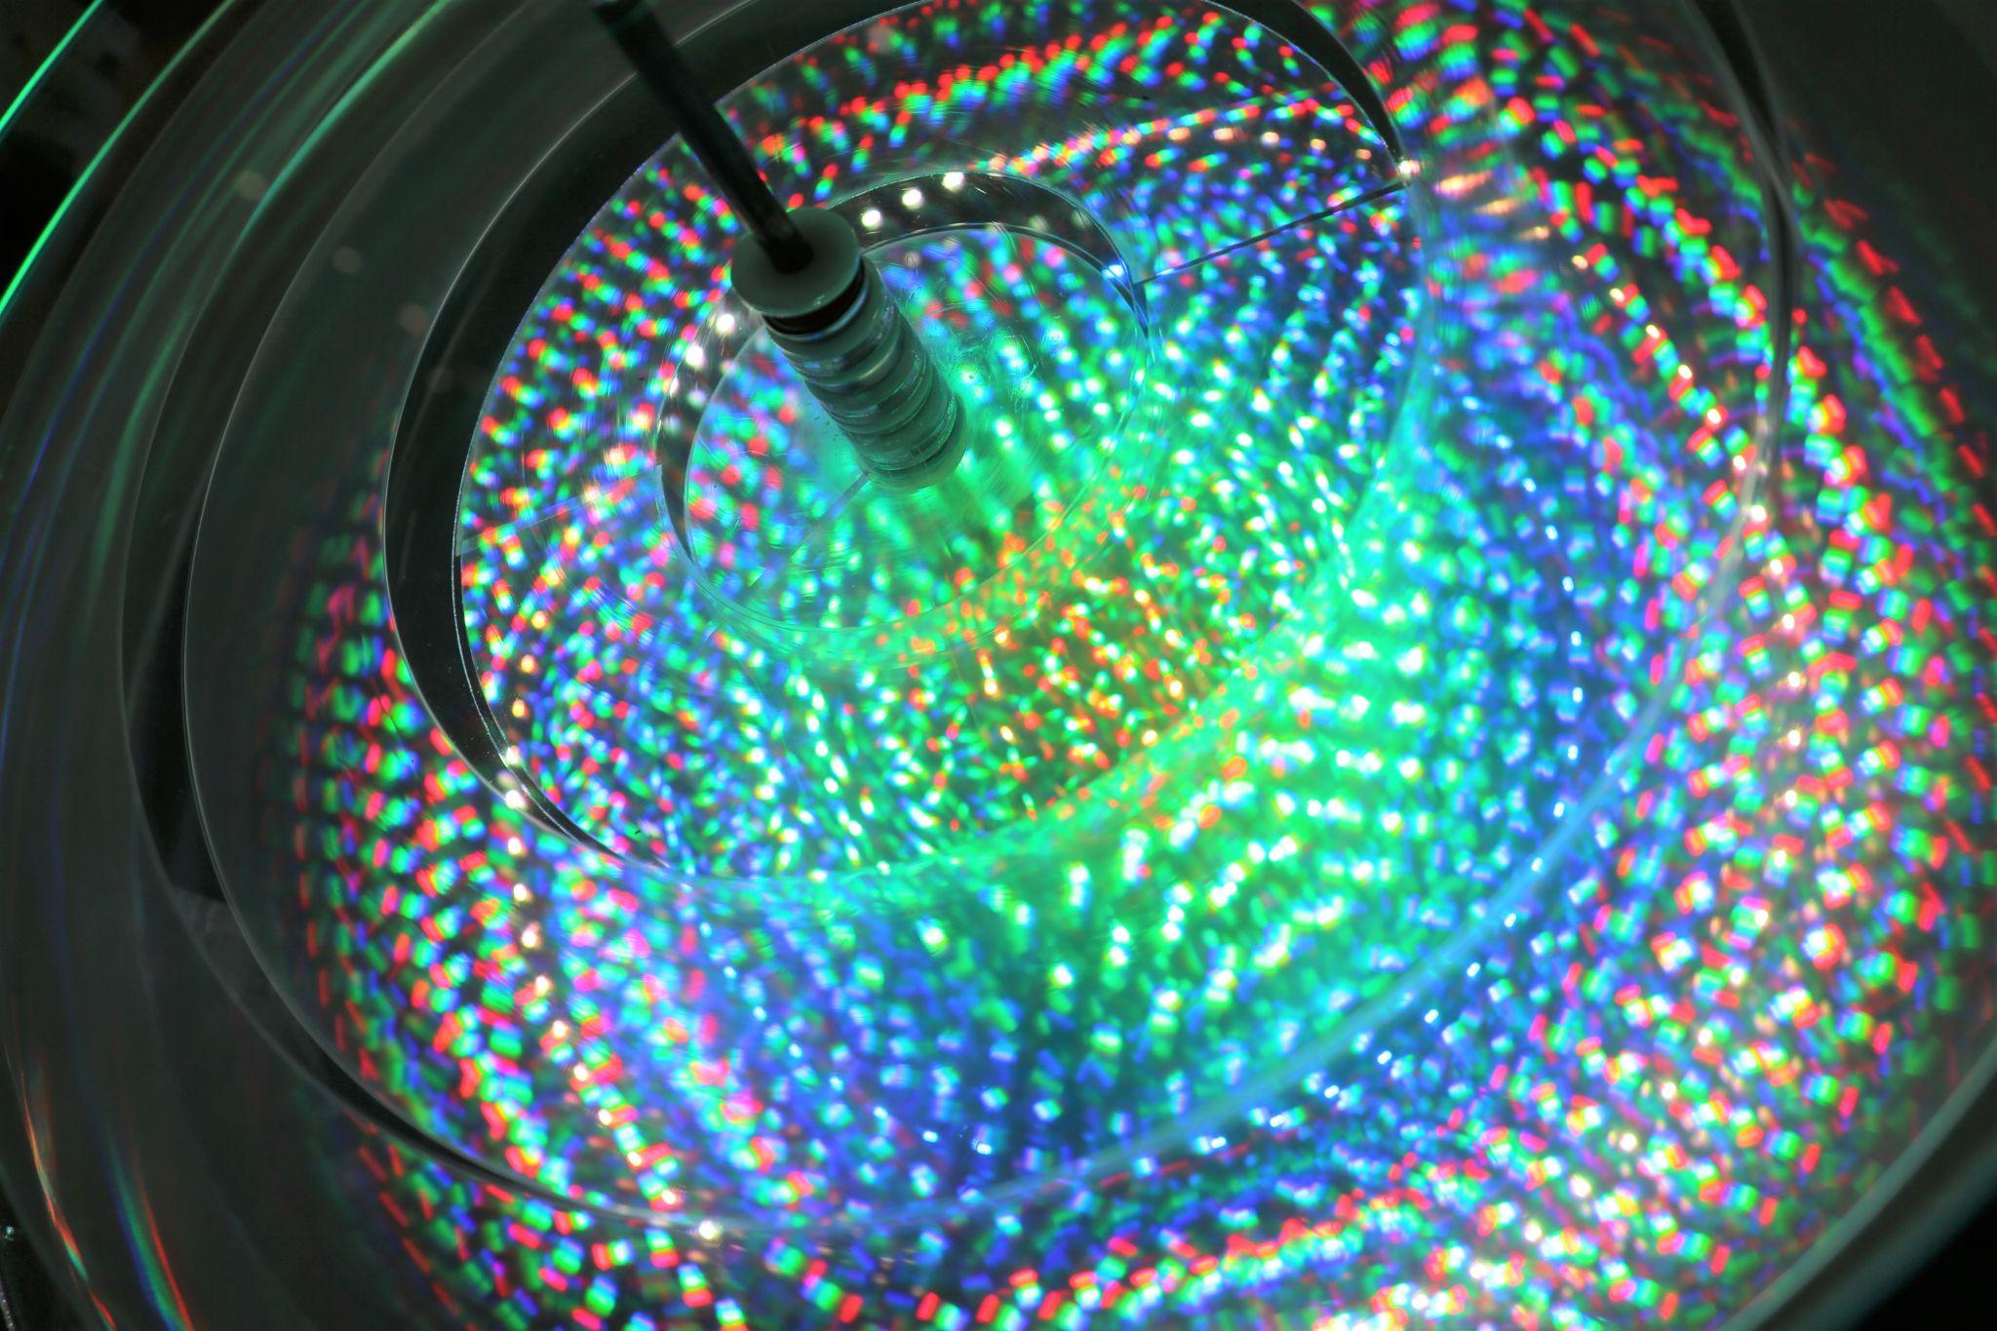
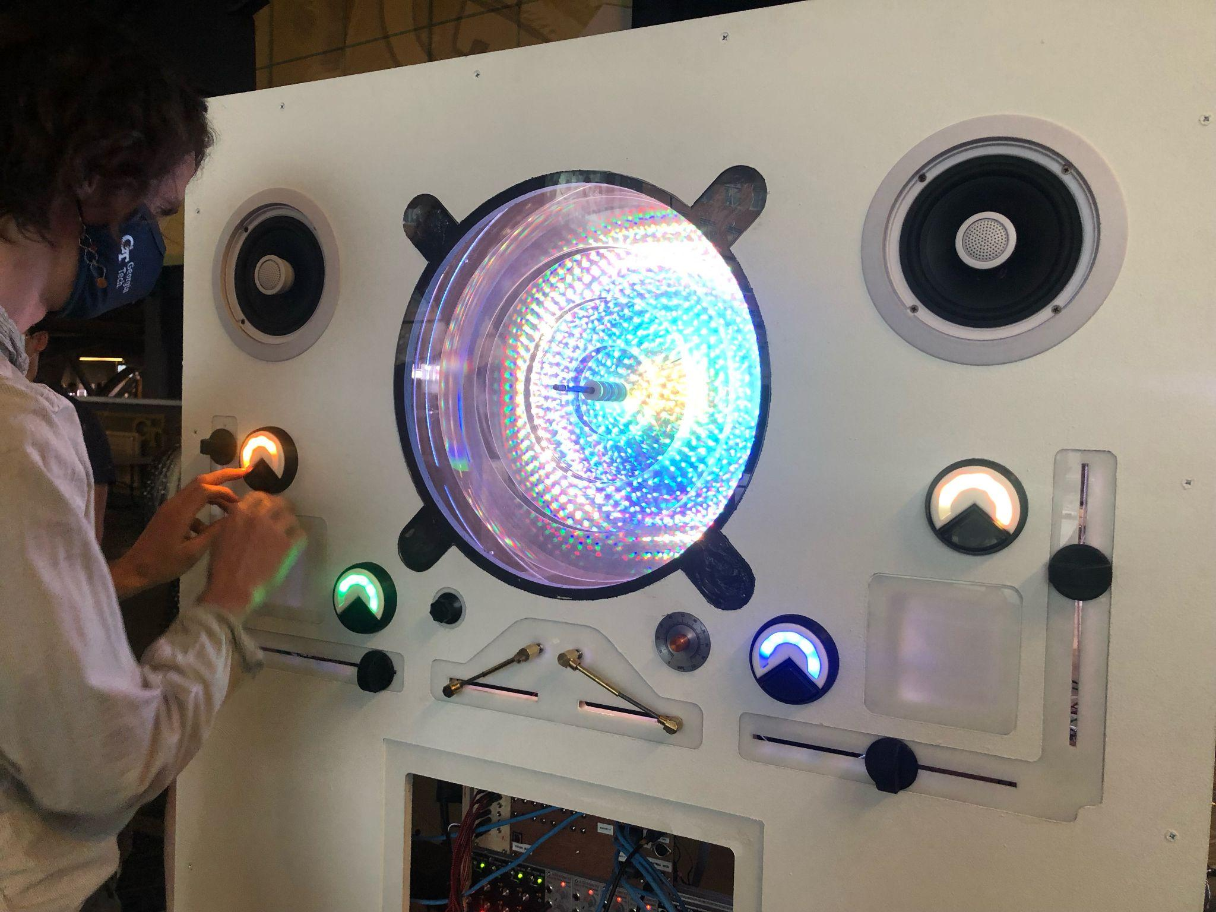
Figure 8. Demonstration of the instrument at the Expo. Notice how the 4 button lights correspond to sliders and to different rings of light inside the visual display.

Figure 9 Close up of visual display, each ring of light represents a different oscillator and different motor speed
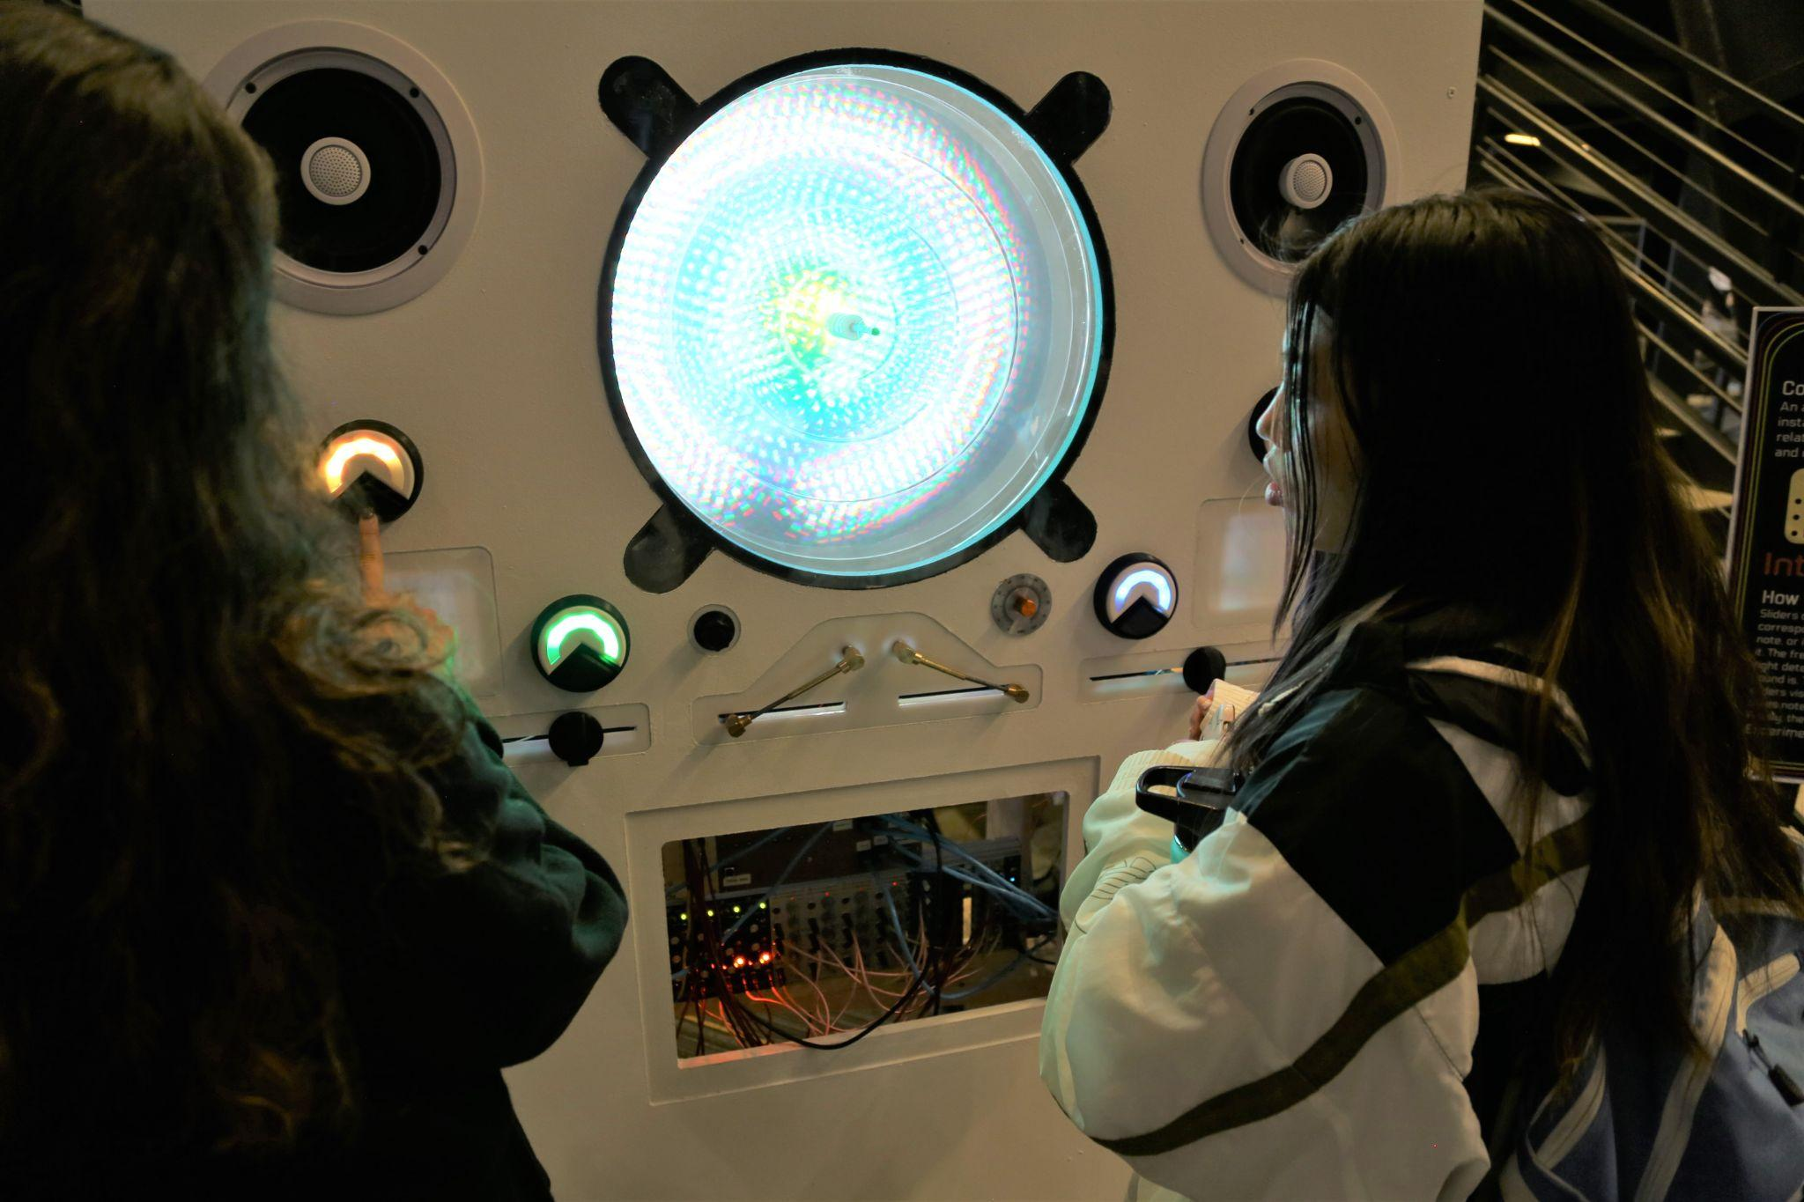
Figure 10 Passerby;s engaged with Harmonic Content

5. Cost Analysis
A detailed cost analysis of parts bought and estimated labor is done in Appendix A. About $3800 was spent on parts for the project. If this was a professional installation and our labor hours were accounted for, they would cost around $12,300 for the 4 of us as professional designers and engineers. The labor estimates are based off of other projects and installations I have worked on as a fabrication specialist or an electronics consultant. To create a piece of interactive art like this, a grant of $17,500 would be sufficient to cover parts and labor.

6. Conclusion
The installation went very well all things considered. The iterative design process for a large interactive art installation took longer than we really had time for, and thus we didn't settle on a (partially) prototyped design until fairly late in the semester. The MDF front panel where all the user interface and visuals mount was not CNC cut until the week before the senior design expo. This only left us a week to fabricate the physical structure and wire everything. This led to much of the physical work being done in the final days of the project. At a certain point in the semester, our system was getting so complex it was impossible to keep building and tearing down to store, we needed the full size installation to continue working on the system. The wiring for the installation was completed mere hours before the Expo, so any software programming had to be done on the fly. There were many electrical faults with the PCB’s we designed, and that took many hours of troubleshooting in the final days.
There are many things that were learned from this process.
- find a dedicated space to work where you can leave materials for the duration of the project. Moving things in and out of a small locker caused wires to short, and we spent too much time troubleshooting parts that were already working due.
- spend time figuring out a test rig for completed PCB’s even if the final product isn't ready for them. Since our PCB’s were so specialized to the synth with many user inputs, led outputs, motor outputs, interconnects between the PCB’s, we didn’t have a test bed for checking functionality until the actual structure was built.
- If possible, physical prototyping (user interface, led placement, etc.) and physical aesthetic design choices need to be specified completely before designing the electrical system. We were simultaneously making changes to the physical system while we were doing electrical testing. This caused problems down the line, but there was no way around that in the 14 week context of the semester. Our PCB’s were built to be expandable and had many outputs and inputs as test and expendable so we were able to accommodate last minute changes.
- have at least a week where the installation is built so you can program the actual machine, as the prototype knobs, buttons, sliders etc are not going to be exactly like the ones in the machine. Also any communications between microcontrollers will take more time to get working than expected, and since the visual MCU needs to be connected to all the LEDs and motors before it can be properly programmed, this must be done after everything is setup and wired.
Overall the installation turned out well, but it needs a lot of work to be ready to be displayed as a public art piece that has people interacting with it all day, everyday. We were ambitious in the scope of what we could accomplish in just 14 weeks. We created a working prototype for the installation and going forward, I believe that a complete rebuild of the structure from the ground up would be necessary to make the installation permanent. It would now be cheaper, happen much faster, and be much more reliable and robust since many of the details and problems have been figured out. I propose that a team of artists, engineers, and designers led by current group members, take what we have done and build a revision 2 to be displayed publicly in the Van Leer Building. There were so many lessons learned from 3D printing custom arcade buttons, to wire management with screw terminals, to motor torque issues, to digital addressable LED problems, to ribbon cables being twisted and backwards, to internal vs external pullup resistors, to interfacing two MCU’s between two custom PCBs. It would be necessary for current team members to be part of the next iteration so the next team does not fail where we did!

7. Leadership Roles
William Kennedy: Group Leader
William is the primary manager of the project and advises members on the musical and visual aspects of the project. He is managing the sourcing of any larger complete hardware components.
Andrew Kim: Web Master
Andrew is primarily working on the software on the processor as well as the peripheral connections. Included in the work is any supported documentation needed for modification, support, maintenance, and expandability.
Savannah Hearn: Financial Manager
Savannah is primarily working on the electric hardware aspects of the project including any custom fabrication of PCBs needed as well as sourcing parts. Savannah also supports the software and fabrication of the project.
Owen Rohm: Marketing and Design
Owen is working to prototype and gauge interest in certain features in order to determine which can go into the final design through surveys put out. Afterwards, Owen’s primary responsibilities lie in the design and manufacturing of the visual display of the system

References
Flow - spiraling pathway of light. Jen Lewin Studio. (2021, September 12). Retrieved September 22, 2021, from https://www.jenlewinstudio.com/portfolio/flow/.
Martin, J. (n.d.). Jean Martin: PETER VOGEL'S INTERACTIVE Sound Art. Peter Vogel: The Sound of Shadows. Retrieved September 21, 2021, from http://vogelexhibition.weebly.com/jean-martin-peter-vogels-interactive-sound-art.html.
“Music and Visual Color: A Proposed Correlation” Alan Wells. Leonardo Vol. 13, No. 2 (Spring, 1980), pp. 101-107 (8 pages). The MIT Press.
Popova, M. (2019, March 19). The magic and logic of color: How josef albers revolutionized visual culture and the art of seeing. Brain Pickings. Retrieved September 20, 2021, from https://www.brainpickings.org/2013/08/16/interaction-of-color-josef-albers-50th-anniversary/.
Wikimedia Foundation. (2021, August 21). Clavier à lumières. Wikipedia. Retrieved September 22, 2021, from https://en.wikipedia.org/wiki/Clavier_%C3%A0_lumi%C3%A8res.

Appendix A - Cost Breakdown
PARTS
date | vendor | part | amount
9/2/2012 | synthcube | 1x vco kit | $99.00
9/24 | duskwork vco | 4x vco | $520.00
9/24 | pjrc | teensys | $152.23
9.24 | perfect circuit | big system | $1,338.01
9.23 | midimuso | midi to cv module | $64.66
9/23 | midimuso | tracking | $7.84
9.27 | digikey | power supply, 32 channel dac | $137.30
9.27 | perfect circuit | mults modules | $195.00
8/6 | digikey | mounting rails | $78.14
8/13 | perfect circuit | eurorack power cable | $32.92
10.31 | jlc pcb | 2 pcbs | $45.69
11.2 | synthcube | jacks and ribbon cable | $33.88
11.2 | mouser | pcb component parts | $99.04
11/9 | amazon | 12V addressable leds | $97.74
11/9 | adafruit | large arcade buttons | $82.81
11/9 | perfect circuit | refund of overage buy | -$170.93
11/16 | servocity | motors and mounting | $176.92
11/16 | servocity | alternative motors | $97.90
11/16 | mouser | power supply, small leds, more teensy | $188.43
11/21 | amazon | multiturn pots | $18.70
11/21 | adafruit | side emitting leds | $110.62
11/28 | homedepot | wood, brackets, hardware etc | $353.46
12/3 | Home Depot | paint supplies | $33.36
LABOR
 | hourly rate | hours spent | total
electronics deisgn | $45.00 | 80.00 | $3,600.00
physical design and CAD work | $45.00 | 80.00 | $3,600.00
electronics fabrication | $30.00 | 40.00 | $1,200.00
physical fabrication | $30.00 | 40.00 | $1,200.00
programming | $45.00 | 40.00 | $1,800.00
troubleshooting | $45.00 | 20.00 | $900.00
TOTALS
Total parts |  |  | $3,792.72
Total labor |  |  | $12,300.00
Grand total |  |  | $16,092.72

